Department of State Hospitals – Napa

RE: ,
SC:
NA:

Subject: Recommendation NOT to extend commitment

Pursuant to Penal Code Section 1026.5(b)(1) please find Napa State Hospital’s recommendation that [First Name] [Last Name] should not be considered for an extension of commitment, as [First Name] [Last Name] does not represent a substantial danger of physical harm to others and she does not have serious difficulty controlling her dangerous behavior

Napa State Hospital is requesting notification from the court when the matter has been calendared. Please fax the hearing notification to (707) 254-2321.

Sincerely,

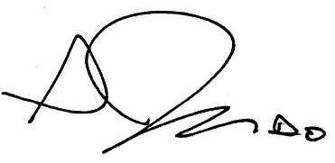
Seth Judd, D.O.
Medical Director

cc: Health Information Management Department, Unit Chart, Program File, CONREP

